International Institute of Professional Studies

Devi Ahilya Vishwavidhalaya

Indore, MP



**PROJECT REPORT**

**ON**

**Indian Clinic (Hospital Management Website)**

This Project is submitted for VI semester

For degree of

Master of Computer Application

Guided By : Submitted By :

Dr. Rahul Singhai Kunal Rawal (IC-2K17-65)

**DECLARATION**

I hereby declare that the project entitled “**Indian Clinic (Website)**”

Which is submitted by **Kunal Rawal (IC-2K17-65)**

for the partialfulfilment of master of computer application (6Years) **VI** **Semester** of

International Institute of Professionals Studies,

DeviAhilya Vishwavidyalaya, Indore

Comprises my own work and due acknowledgement has been made in text to all other material used.

The mater embodied in this project work is authenticated and is genuinely done by me and has not been submitted to this university or any other university / institute.

We have completed this project work during our VI semester session under the supervision of Dr. Rahul Singhai Senior Lecturer, IIPS, DAVV, Indore.

Signature of student: 

Date: 14th July, 2020

Place: Indore

**CERTIFICATE FROM GUIDE**

It is to certify that project on " **Indian Clinic (Hospital Management Website)**” which is submitted by **Kunal Rawal (IC-2K17-65)** to International Institute ofProfessional Studies , Devi Ahilya Vishwavidyalaya , Indore hasbeen completed under my supervision and the work is carriedout and presented in a manner required for its acceptance inpartial fulfilment for the award of degree of “ Master of Computer Application (6Yrs) ” Semester VI.

**Project Guide**

Signature:

**Name:** Dr. Rahul Singhai

**Date: 14th July, 2020**

**CERTIFICATE**

It is to certify that project on " **Indian Clinic (Hospital Management Website)**” which is submitted by **Kunal Rawal (IC-2K17-65)** to International Institute ofProfessional Studies, Devi Ahilya Vishwavidyalaya, Indore and here by accord our approval of it as a study carried out and presented in a manner required for its acceptance in partial fulfilment for the award of degree of “Master Of Computer Application (6Yrs)” Semester VI.

**Internal Examiner** **External Examiner**

Signature : Signature :

Name : Name :

Date : Date :

**ACKNOWLEDGEMENT**

I acknowledge my sincere thanks to those who have contributed significantly to this project. It is a pleasure to extend deep gratitude to our internal guided Dr. Rahul Singhai, IIPS, for his valuable guidance and support and to continuously prompt us for the progress of the project. I thank him for his valuable suggestion towards my project, which helped us in making this project more efficient and user friendly.

We thank and acknowledge each and every ones efforts that helped me in some or the other way for small and significant things.

**ABSTRACT**

The project entitled “Indian Clinic” provides a User Friendly Working Platform for the Hospitals. My Project includes registration of patients, storing their details into the system, and also computerized appointment booking from the user and from reception. My Website has the facility to give a unique id for every patient and stores the details of every patient and staff automatically. The booked appointment from the patients are visible to doctor and reception, they either can cancel or confirm the appointment according to them. User can search doctors and the details of the patient using the id.

User can book the appointments from Website, by first, registering himself and then sign in. Website is accessible either by an administrator or receptionist directly. The interface is user-friendly. The user data is well protected for personal use.

An attempt is made to introduce new concept in the project. This project has been developed in such a way to replace the human resource with more efficient web resources.

**TABLE OF CONTENTS**

Topics Page No.

1. **INTRODUCTION** 
   1. Background problem
   2. Purpose
   3. Scope
   4. Methodology
2. **AIM & OBJECTIVE OF STUDY**
   1. Aim
   2. Objective
3. **SYSTEM DEVELOPMENT LIFE CYCLE** 
   1. **Feasibility Study**
      1. Economical feasibility
      2. Technical feasibility
      3. Legal feasibility
   2. **Analysis**
      1. Existing system
      2. Proposed system
      3. Data flow diagram (DFD)
   3. **Planning** 
      1. Specific requirement
      2. External interface requirement
      3. Hardware requirement
      4. Software requirement
      5. Performance requirement
   4. **Design**
      1. Entity definition
      2. Attribute definition
      3. Relationships
      4. E-R Diagram
      5. Flow diagram
   5. **Implementation**
   6. **Testing** 
      1. Unit testing
      2. Integration testing
      3. Validation testing
   7. **Maintenance**
4. **FUTURE SCOPE OF APP**
5. **CONCLUSION**
6. **BIBLIOGRAPHY & REFERENCES**

**INTRODUCTION**

**1.1 Background problem**

**Lack of immediate retrievals.** The information is very difficult to retrieve and to find particular information like to find out about the patient’s history, the user has to go through various registers. This results in inconvenience and wastage of time.

**Lack of immediate information storage.** The information generated by various transactions takes time and efforts to be stored at right place.

**Lack of prompt updating**. Various changes to information like patient details or appointment rescheduling are difficult to make as paper work is involved.

**1.2** **Purpose**

Main Purpose of a Hospital Management System:

* Design a system for better patient care.
* Reduce hospital operating costs.
* Provide MIS (Management Information System) report on demand to management for better decision making.
* Better co-ordination among the different departments.
* Any user can view or update data easily.
* Administrator is the only one with rights to change update and modify data in the database.
* Patient management (scheduling, registration and long-term care).

**1.3 Scope**

* Web based application which will help in overall management of various departments with higher accuracy.
* The modules of hospital management software are user-friendly and easy to access.
* A Web Application will reduce manual efforts.
* This system will work efficiently and correctly as far a computer technology is concerned.
* Reduces **scope** for Error.

**1.4 Methodology**

A methodology is a model, which is employed for the design, planning, implementation and achievement of the project objectives. Methodology has many research dimension and methods. Methodology is the underlying principles and rules that govern system method, on the other hand it is a systematic procedure for a set of activities. In designing Hospital Management System, the following system development methodology will be used.

System Development Lifecycle In developing Hospital Management System, the following steps will be taken:

**Planning**

A project plan will be developed as well as other planning documents. It will provide the basis for acquiring the resources needed to achieve a solution. This phase will ensure that the problem that will be solved will be the one that needed to be solved.

**Analysis**

At this point, the manual system in place will be analyzed to determine where the problem is, in an attempt to solve the system. This step will involve breaking down the system in different pieces to analyze the situation, analyzing project goals, breaking down what needed to be created and attempting to engage users so that definite requirements could be defined. Under analysis, Requirement gathering is the most crucial aspect as many times communication gaps arise in this phase and this leads to validation errors and bugs in the software program. Therefore, the following techniques will be used in analysis to gather information.

a) **Semi-structured interviews** Semi-structured interviews are conducted with a fairly open framework which allow for focused, conversational, two-way communication. They will be used both to give and receive information. In the process of developing the system, the development team will interview the data entrants at hospital in order to identify the processes, obtain specific quantitative and qualitative information from the interviewees, obtain general information relevant to data entry, and to Gain a range of insights on the process of the system. This tool will be used as a data collection methodology of choice because it is; less intrusive to those being interviewed as the semi-structured interview encourages two-way communication.

b) **Direct Observation** Direct Observation is a method in which a researcher observes and records behavior / events / activities / tasks / duties while something is happening. This will be used in correspondence to interviewing in order to gain a more live view of the Hospital’s current management system. Direct observation will be used as a research methodology of choice in designing the management system for Hospital because; Observations give additional, more accurate information on behavior of people than interviews or questionnaires.

**c) Using available information** This is a data collection method that involves the process of examining and evaluating already existent literature material to obtain facts and data regarding a specific subject. Locating these sources and retrieving the information will help in data collection. In the development of the hospital management system, this research methodology will be mainly used in the analysis and design phases of the system development process. This is because it will permit the researcher to analyze changes in trends.

**Design**

In systems design the design functions and operations will be described in detail, including screen layouts, process diagrams and other documentation. Design elements will describe the desired system features in detail, and generally will include functional screen layout diagrams, pseudo code, and a complete entity-relationship diagram.

**AIM & OBJECTIVE OF STUDY**

**1. Aim:**

The aim of the study is to automate the Hospital Management System.

The application is for automation of Hospital Management System.

It has 4 level of users

Administrator level

User level

Reception level

Doctor Level

The application includes:

Information on Patient

Appointment Booking and its information

Details of prescription given to patients

Staff information

Admin Panel

Patient Feedback information

Services

**2. Objective:**

* **To have planned approach towards working:** The working in the organization will be well planned and organized. The data will be stored properly in data stores, which will help in retrieval of information as well as its storage.
* **To have high accuracy:** The level of accuracy in the proposed system will be higher. All operation would be done correctly and it ensures that whatever information is coming from the centre is accurate.
* **To increase reliability:** The reliability of the proposed system will be high due to the above stated reasons. The reason for the increased reliability of the system is that now there would be proper storage of information.
* **To reduce redundancy:** no information is repeated anywhere, in storage or otherwise. This would assure economic use of storage space and consistency in the data stored.
* **To have immediate retrieval of information:** Any type of information would be available whenever the user requires.
* **To have immediate storage of information:** In manual system there are many problems to store the largest amount of information.
* **To easy operation:** The system should be easy to operate and should be such that it can be developed within a short period of time and fit in the limited budget of the user.

**Systems Development Life Cycle** **(SDLC)**

System Development Life Cycle is a conceptual model used in software development projects. In this method, there is a possibility of combining two or more project management methodologies for the best outcome. Therefore we have used waterfall Model along with SDLC. SDLC also heavily emphasizes on the use of documentation and has strict guidelines on it.

**Waterfall Model**

This is the legacy model for software development projects. This methodology has been in practice for decades before the new methodologies were introduced. In this model, development life cycle has fixed phases and linear timelines. The Waterfall Model is a sequential software development process, on which progress is seen as steadily downwards (like waterfall ) through phases of requirement, design, implementation, verification and maintenance.

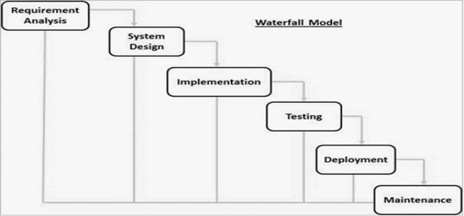

**3.1 Feasibility study**

Feasibility is a measure of how beneficial the development of the information system will be to an organization .This is done by investigating the existing system in the area under investigation or generally ideas about a new system. It is a test of a system proposal according to it's workability, impact on the organization, ability to meet user needs, and effective use of resources. It focuses on three major questions:

1. What are the user’s demonstrable needs and how does a candidate system meet them?

2. What resources are available for given candidate systems? Is the problem worth solving?

3. What are the likely impacts of the candidate system on the organizations? How well does it fit within the organization’s master MIS plan?

Each of these questions must be answered carefully. They revolve around investigation and evaluation of the problem, identification and description of candidate systems, specification of performance and the cost of each system, and final selection of the best system.

Three key considerations are involved in the feasibility analysis:

1. Economic

2. Technical

3. Legal

**3.1.1 Economic feasibility**

Economic analysis is the most frequently used method for evaluating the effectiveness of a proposed system. It is more commonly known as cost benefit analysis, the procedure to determine the benefits and saving that are expected from a candidate system and compare them with costs. If the benefits outweigh costs then a decision is made to design and implement the system. Otherwise make alterations in the proposed system.

The innovation of the new system has much influence on the economical side of the company. Manual system is highly cost driven due to the high labour costs. So if a company registers with the Indian Clinic Website, they can automate their day -to - day activities. Thus the system is economically feasible.

**3.1.2 Technical feasibility**

In examining Technical feasibility of the system, more importance

is given to the hardware interaction part of the system. The

assessments of technical feasibility centers on the existing system and

to what extent it can support the proposed addition. This was based on

an outline design of system requirements in turns of inputs, files,

programs, procedures, and staff. It involves financial considerations to

accommodate technical enhancements. According to the definition of technical feasibility the compatibility between front-end and back-end is very important. In our project the compatibility of both is very good. The compatibility of Java (jdk 8.0) and MYSQL 8.0 is very good. The speed of output is very good, when we enter the data and click button then the response time is very fast and give result very quickly. I never find difficulty when used complex query or heavy transaction. The speed of transaction is always smooth and constant. This software provides facility to communicate data to distant location.

The designing of front-end of any project is very important so we select **JSP** as front-end due to following reason:

• Easy implementation of code.

• Well define interface with database.

• Both html and java code can be written in **JSP** easily.

• Easy debugging.

I have selected MYSQL 8.0 because of the following number of reasons.

• Able to handle large data.

• Security.

• Robust RDBMS.

• Backup & recovery.

With the help of above support we remove defect of existing software. To ensure that system does not halt in case of undesired situation or events. Problem affected of any module does not affect any module of the system. A change of hardware does not produce problem.

**3.1.3 Legal feasibility**

People are inherently resistant to change, and computers have

been known to facilitate change. An estimate should be made about the reaction of the user staff towards the development of a computerized system.

Computer installations have something to do with turnover,

transfers and changes in job status. The introduction of a candidate

system requires special effort to educate, sell and train the staff for

conducting the business.

The system is designed such that even a computer ignorant

person can interact with the system freely. So the system requires not

much effort to train and educate people, the system is that much legally feasible.

**3.2 Analysis**

Analysis is the process of breaking a complex topic or substance into smaller parts in order to gain a better understanding of it.  
 I divided my project into small modules like interface module has many sub-parts which were individually made to achieve the desired goal.

**3.2.1 Existing system**

Existing System Hospitals currently use a manual system for the management and maintenance of critical information. The current system requires numerous paper forms, with data stores spread throughout the hospital management infrastructure. Often information (on forms) is incomplete, or does not follow management standards. Forms are often lost in transit between departments requiring a comprehensive auditing process to ensure that no vital information is lost. Multiple copies of the same information exist in the hospital and may lead to inconsistencies in data in various data stores.

**3.2.2 Proposed system**

The Hospital Management System (HMS) is designed for Any Hospital to replace their existing manual, paper based system. The new system is to control the following information; patient information, room availability, staff and appointment schedules, and patient prescription. These services are to be provided in an efficient, cost effective manner, with the goal of reducing the time and resources currently required for such tasks.

**3.2.3 Data Flow Diagram**

A data flow diagram (DFD) is a graphical representation of the "flow" of data through an information system, modeling it's process aspects. A DFD is often used as a preliminary step to create an overview of the system without going into great detail, DFDs can also be used for the visualization of data processing (structured design).

A DFD shows what kind of information will be input to and output from the system, how the data will advance through the system and where the data will be stored.

Figure DFD should be placed here

**3.3 PLANNING** Planning is the process of thinking about the activities required to achieve a desired goal. It involves the creation and maintenance of a plan, such as psychological aspects that require conceptual skills. There are even a couple of tests to measure someone’s capability of planning well.   
 I have plan our interface in which there will be multiple options that will help user to access the intended information about hospital.

**3.3.1 Specific requirements**

Since the User, Admin, Doctors are the main target group of our software, we will only concern about some important functions for the admin, the user and the doctors.

Administrator:-

* All the details related to patients, doctors, staff, appointments, feedbacks are accessible to admin.
* Admin can add, update, remove the details of doctor.
* Admin can either cancel the appointments or schedule the appointments.
* Admin can remove patient details.
* Admin can add, update, remove the details of staff.

User:-

* User can book the appointment.
* User can view the status of the appointment.
* Users are provided the prescription online too by the doctor.
* Users can give feedback to the hospital.

Doctor:-

* Doctors can view or edit their own profile which is visible to patients.
* Doctors can either cancel or confirm the appointments.
* Doctors can give prescription to the desired patients.

Reception:-

* Reception can view Patient and doctor details.
* Reception can either cancel or confirm the appointments according to doctor’s availability.
* Reception can assign the desired doctor and schedule time for the appointment.

**3.3.2 External Interface Requirements**

It include the following interfaces

* User interfaces
* Software interfaces
* Hardware interfaces

**User Interfaces:-**

The interface must be easy to understand. The user interface includes:

* **screen formats/ organization**: The introductory screen will be thefirst to be displayed which will allow the users to go to other pages.
* **Window format/ organization**: When the user chooses some otheroption, then the information pertaining to that choice will be displayed in a new window which ensures multiple windows to be visible on the screen and the users can switch between them.

**Hardware Interfaces:-**

1. Server side hardware

· Hardware recommended by all the software needed.

· Communication hardware to serve client requests

2. Client side hardware

* Hardware recommended by respective client’s operating system and

web browser.

* Communication hardware to communicate the server.

**Software Interfaces:-**

Server side software

* Web server software
* Server side scripting tools: javascript
* Database tools
* Compatible operating system: windows operating system, linux operating system etc.

communications interfaces:-

http : Hypertext Transfer Protocol is a transaction oriented client / server

protocol between web browser & a web server.

TCP/IP**:** Transmission Control Protocol / internet protocol , the suite of

communication protocols used to connect hosts of the internet.

Tcp/ip uses several protocols, the two main ones being TCP and IP.

**3.3.3 Hardware Requirements**

**Processor:** Intel Pentium 4

**Ram :** 256 MB

**Cache Memory:** 512 KB

**3.3.4 Software Requirements**

**Operating System:** Windows OS, Linux OS etc.

**Front End:** JSP, HTML, CSS, JAVASCRIPT

**Back End:** Java Servlets, MySql, JSP

**Web server:** Internet Connectivity

**Browser:** Chrome, Microsoft edge, opera etc.

**3.3.5 Performance Requirements**

* System should be able handle multiple users
* Database updating should follow transaction processing to avoid data

inconsistency.

**3.4 DESIGN**

Design is the first step in the development phase for any techniques and principles for the purpose of defining a device, a process or system in sufficient detail to permit its physical realization.

Once the software requirements have been analyzed and specified the software design involves three technical activities - design, coding, implementation and testing that are required to build and verify the software.

The design activities are of main importance in this phase, because in this activity, decisions ultimately affecting the success of the software implementation and its ease of maintenance are made. These decisions have the final bearing upon reliability and maintainability of the system. Design is the only way to accurately translate the customer’s requirements into finished software or a system.

Design is the place where quality is fostered in development.

Software design is a process through which requirements are translated into a representation of software. Software design is conducted in two steps. Preliminary design is concerned with the transformation of requirements into data.

**3.4.1 Entity definition**

Entity are the principle data object about which information is to be collected. Entities are either concrete or abstract such as a person, place, things or event which have relevant to database.

**3.4.2 Attribute definition**

The attribute that are identified as part of the entities are listed along with their descriptions, data types and attribute name.

**3.4.3 Relationships**

* One –to –one
* One –to –many
* Many –to –many

**3.4.4 E-R Diagram**

An entity relationship model, also called an entity - relationship (ER) diagram, is a graphical representation of entities and their relationships to each other, typically used in computing in regard to the organization of data within databases or information state. An entity is a piece of data - an object or concept about which data is stored.

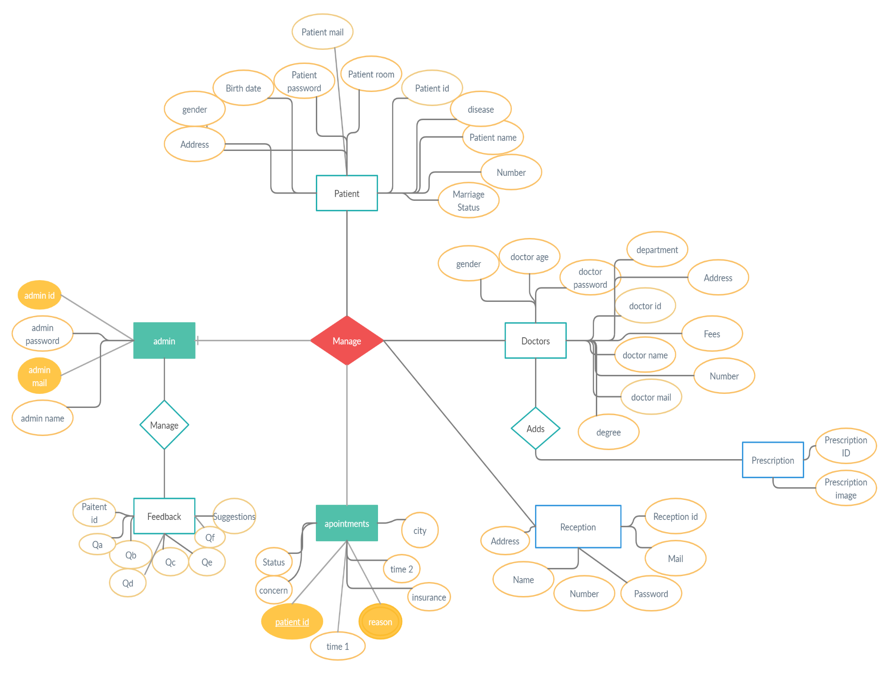

**3.4.5 FLOW CHART**

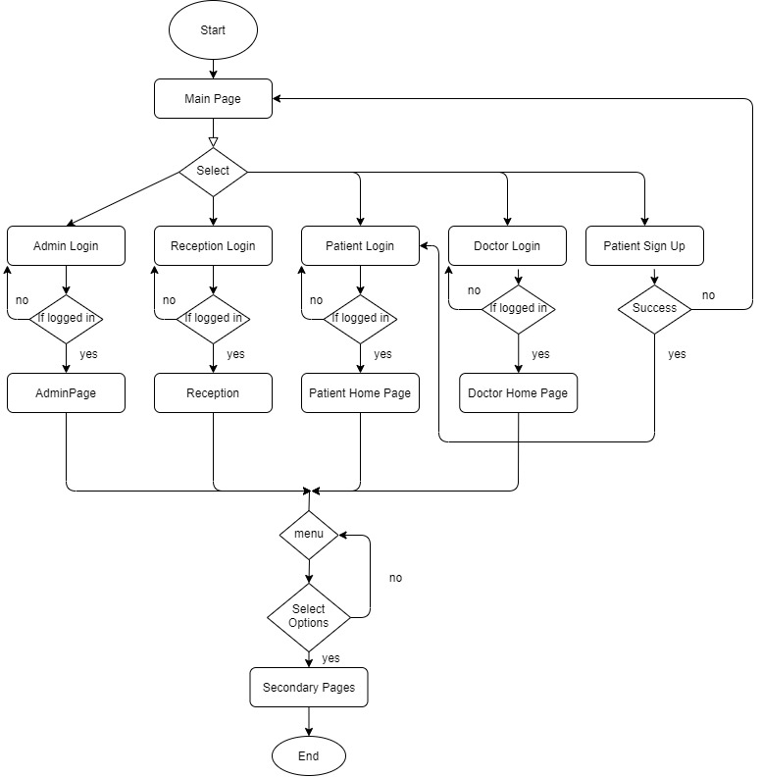

**3.4.6 Admin Activity**

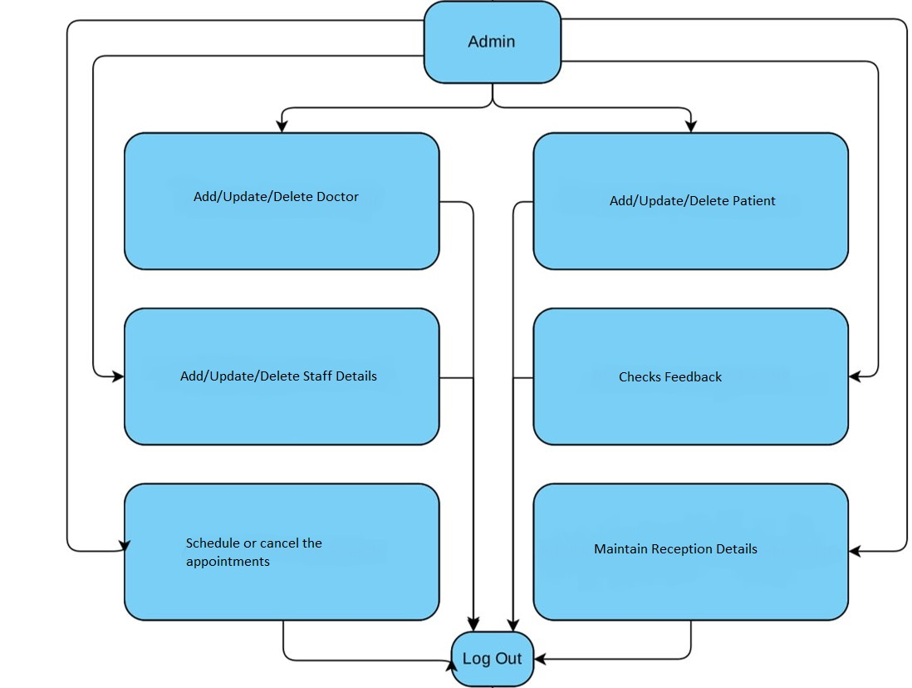

**3.4.5 User Activity**

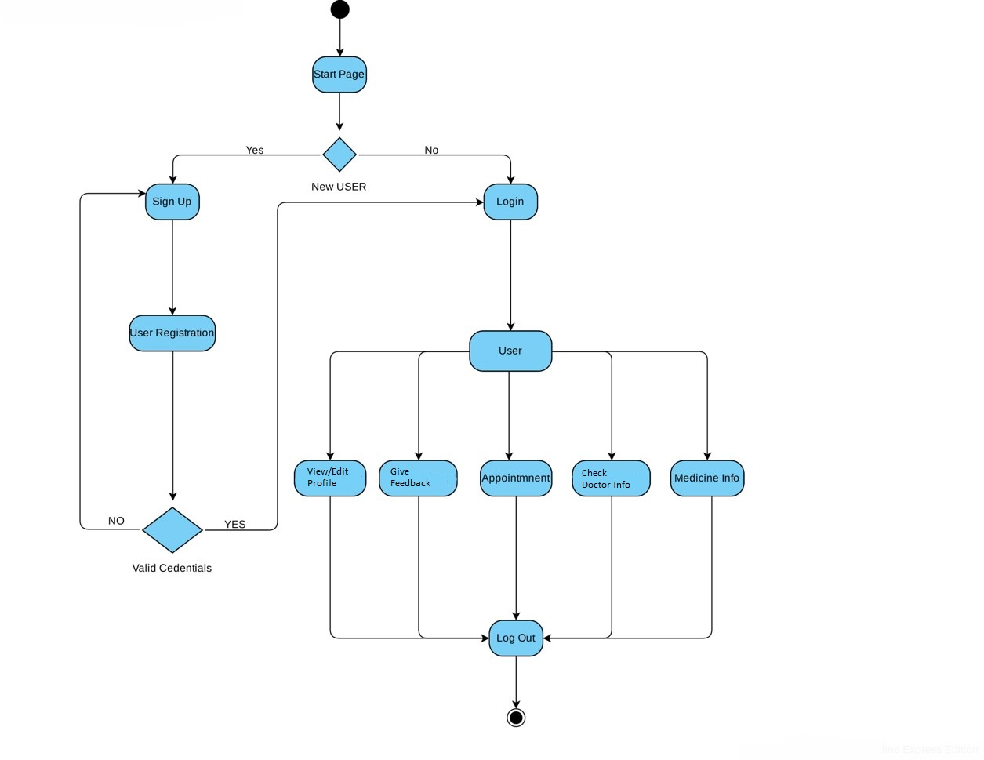

**3.5 IMPLEMENTATION**

Implementation is the stage in the project where the theoretical design is turned into a working system and is giving confidence on the new system for the users that it will work efficiently and effectively .It involves careful planning, investigation of the current system and it's constraints on implementation , design of methods to achieve the change over ,an evaluation , of changeover methods . Apart from planning major task of preparing the implementation are education and training of users.The more complex system being implemented, the more involved will be the system analysis and the design effort required just for implementation.

An implementation co-ordination committee based on policies of individual organization has been appointed .The implementation process begins with preparing a plan for the implementation of the system.

According to this plan ,the activities are to be carried out ,discussions are made regarding the equipment and resources and the additional equipment has to be acquired to implement the new system.

Implementation is the final and important phase .This is the most critical stage in achieving a successful new system and in giving the users confidence that the new system will work is effective .

The system can be implemented only after thorough testing. This method also offers the greatest security since the old system can takeover if the errors are found or inability to handle certain type of transactions while using the new system .

**3.6 TESTING**

System testing is the stage of implementation, which is aimed at ensuring that the system works accurately and efficiently before live operation commences .Testing is vital to the success of the system . Testing is the process of executing a program with the explicit intention of finding errors that is making the program fail . The tester may analysts , programmer or a specialist trained for software testing ,is actually trying to make the program fail .Analysts know that an effective testing program does not guarantee system reliability .Therefore reliability must be designed into the system.

Testing brings all the pieces together into a special testing environment, then checks for errors, bugs and interoperability.

**3.6.1 Unit Testing**

In unit testing we have to test the programs making up the system. For this reason unit testing is sometimes called as the program testing. The software units in a system are modules and routines that are assembled and integrated to perform a specific function.

Unit testing focuses first on modules, independently of one another , to locate errors .This enables ,to detect errors in coding

and logic that are contained within the module alone .Unit testing can be performed from the bottom up ,starting with the lowest level modules and proceeding one at a time .Unit testing is done for each module in online test management tool. This ensures that the value we enter match with the data type and within the specified limit.

**3.6.2 Integration Testing**

Data can be lost across any interface, one module can have an adverse effect on another ,sub functions when combined ,may not produce the desired major functions .Integration testing is a systematic testing for conducting tests to uncover errors associated within the interface .The objective is to take unit tested modules and build a program structure . All the modules are combined and tested as a whole. Here correction is difficult because the vast expenses of the entire program complicate the isolation of causes. Thus in the integration testing step, all the errors are corrected for the next testing steps. In online test management tool, each module is integrated and tested .This testing provides the assurance that the application is well integrated functional unit with smooth transition of data .

**3.6.3 Validation Testing**

At the culmination of integration testing ,software is completely assembled as a package ; interfacing errors have been recovered and corrected and a final series of a software tests - validation tests begin. Validation testing can be defined in many ways but a simple definition is that validation succeeds when the software functions in a manner that can be reasonably expected by the customer.

Invalidation testing if user wants to enter the numeric value he can only enter the numeric value not the text value. For e.g. :in phone number field user can only enter numeric value to it .The system is user friendly with user guide and messages to explain further procedures .An attempt has been made to perfect the process by incorporating validation at each level .

* 1. **MAINTENANCE**

During the maintenance stage of the SDLC, the system is assessed to ensure it does not become obsolete. This is also where changes are made to initial software. It involves continuous evaluation of the system in terms of its performance.

In the maintenance phase of SDLC we can add-on new content and update our application according to change in information of the institute.

**SCREENSHOTS**

**Main Page**

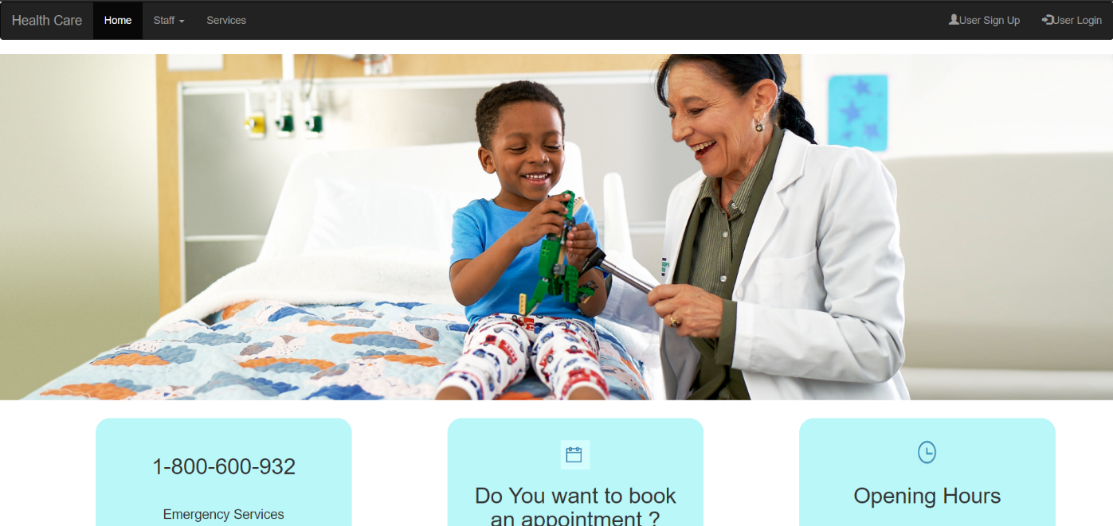

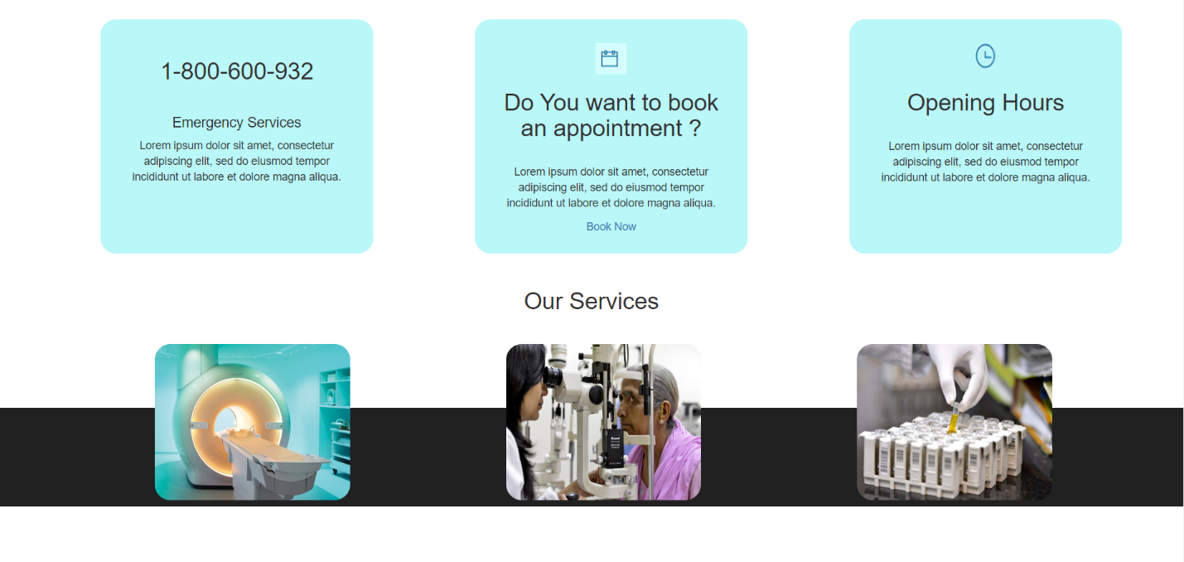

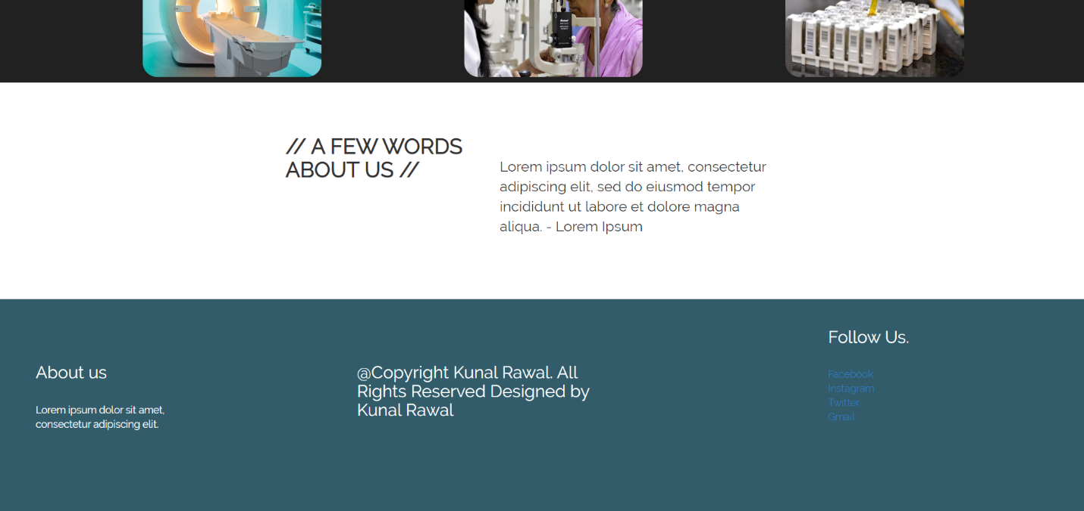

Login Pages

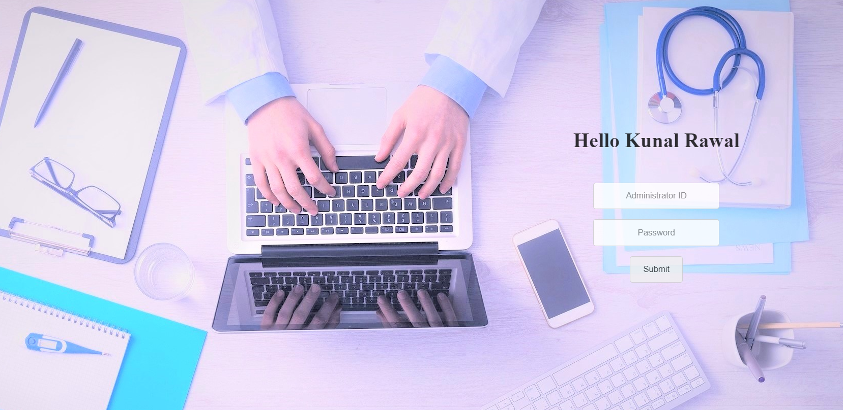

Admin Page

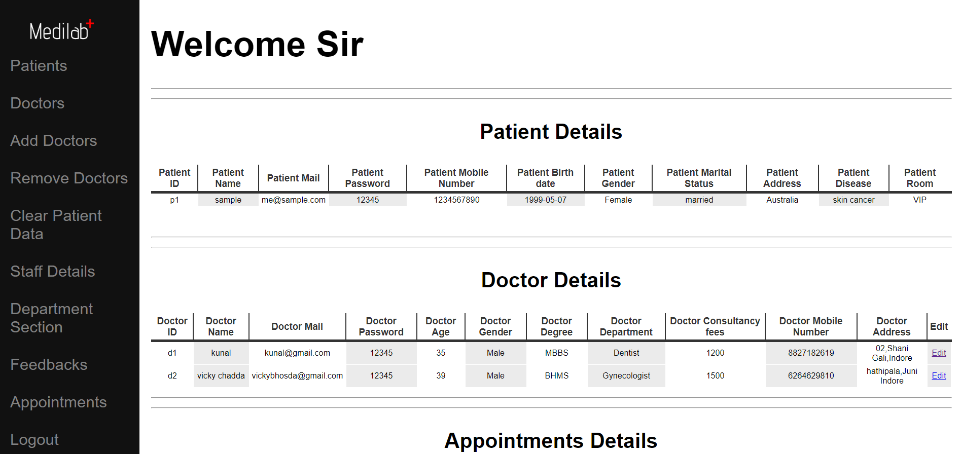

Patient Sign Up

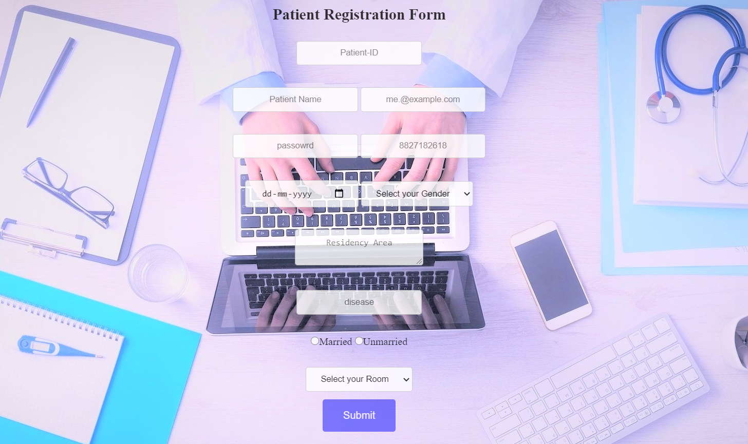

Patient Home Page

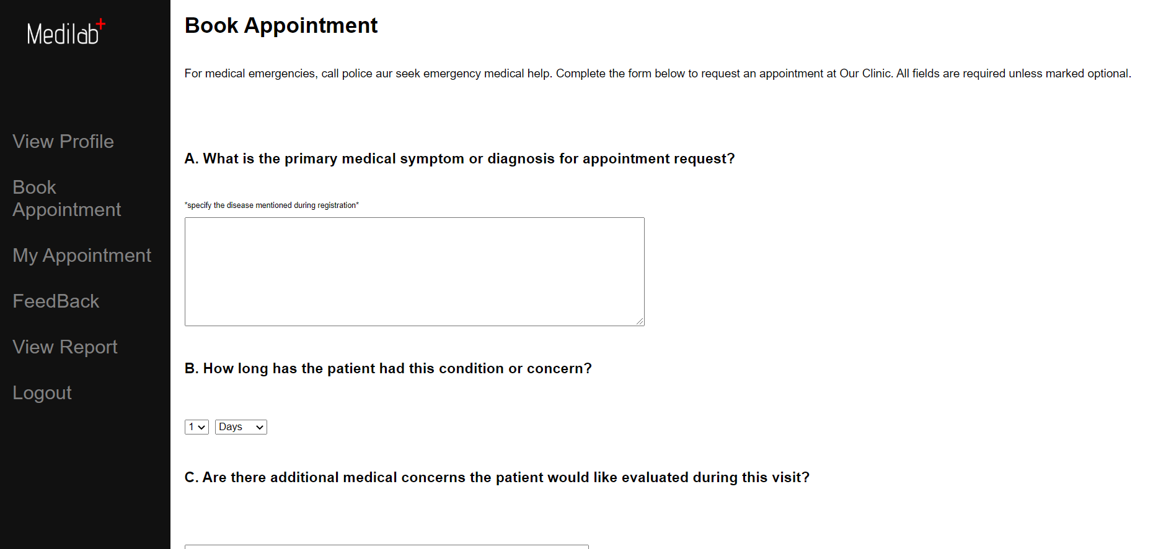

Also a COVID tracker is present on the website so that the Users can get to know about Number of Cases in our Country

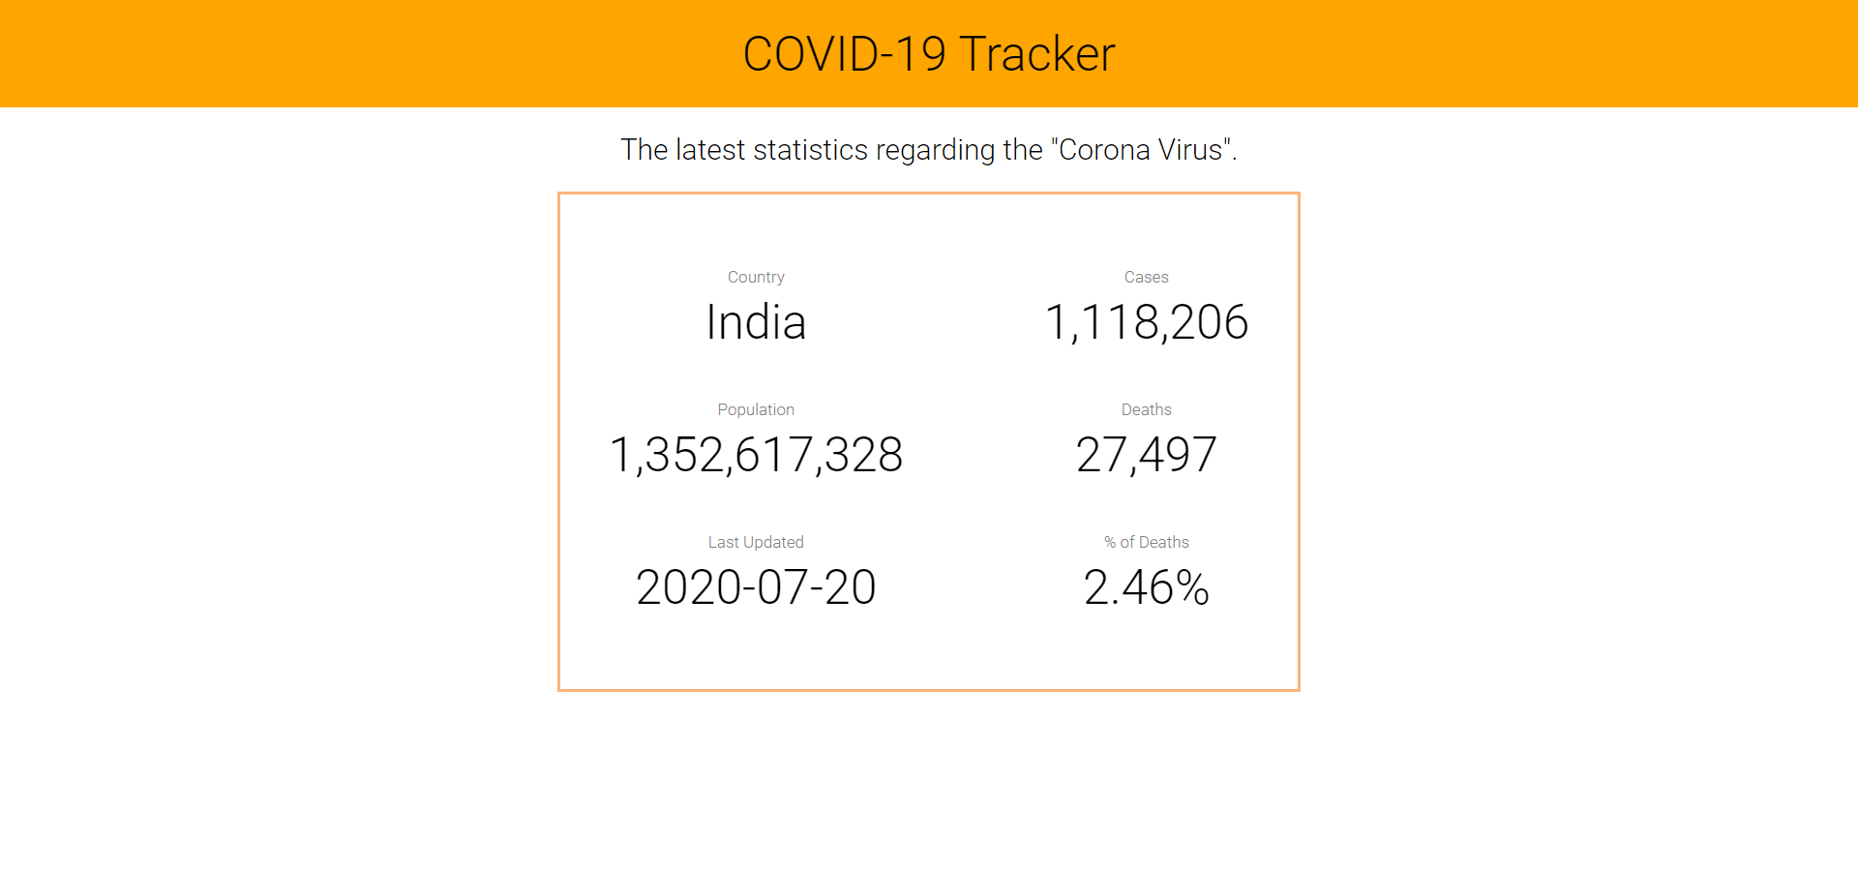

**Future Scope of Website**

In the future version of these application we can enhance following features in our Indian Clinic (The Hospital Management Website) which will make our web application more efficient and user effective then now features can be added in future are:

* Online billing system will be provided so that the patient can pay the due amount in a few click. Also, he will get the proper bill related to the expenses.
* Ambulance booking system – this system will help the user to book the ambulance for emergency cases.
* Purchase of medicine directly from the website. If the medical store of hospital is available he/she can purchase medicines directly from the hospital.

**Conclusion**

The package was designed in such a way that future modifications can be done easily. The following conclusion can be deduced from the development of the project.

* Automation of the entire system improves the efficiency
* It provides a friendly graphical user interface which proves to be better when compared to the existing system.
* It gives appropriate access to the authorized users depending on their permissions.
* It effectively overcomes the delay in communications.
* Updating of information becomes so easier.
* System security, data security and reliability are the striking features.
* The System has adequate scope for modification in future if it is necessary.

**Bibliography and Reference**

**1. Reference Books**

Java : The Complete Reference , Eighth Edition, Mc Graw - Hills

JSP : The Complete Reference , JSP2.0, Mc Graw - Hills

DBMS : Elmasri and Navathe “ Fundamentals of Database System”, 3 rd edition

HTML : HTML by Herbert's child

**2. Other Documents and Resources**

http://www.w3schools.com/html/

http://www.w3schools.com/css/

http://www.w3schools.com/js